An Intelligent AI-Driven System for Student Mental Health Assessment

and Early Risk Detection

Rithikka J
Department of Artificial Intelligence and Data Science
Chennai Institute of Technology (An autonomous Institution)
Chennai, India rithikkaj.aids.2022@citchennai.net

Rajapreethi V
Department of Artificial Intelligence and Data Science
Chennai Institute of Technology (An autonomous Institution)
Chennai, India rajapreethiv@gmail.com

Abstract—: The growing academic workload, social pressures, and evolving lifestyle patterns among students have led to a substantial increase in mental health challenges, including stress, anxiety, and depression. However, existing mental health support systems remain largely reactive, fragmented, and difficult to access, resulting in delayed identification and intervention for at-risk students. To address this critical research gap, this study proposes an intelligent AI-driven system for student mental health assessment and early risk detection.The proposed system incorporates an AI-based decision analysis framework that evaluates student self-assessment responses to extract key psychological indicators and systematically classify mental health risk levels. Through the application of intelligent rule-based logic, the system analyzes behavioral and emotional patterns to detect early warning signs and determine the severity of mental health conditions. This framework is integrated into a secure web-based platform that delivers real-time assessment outcomes, personalized feedback, and self-help recommendations while ensuring data privacy and confidentiality. Furthermore, the system supports continuous mental health monitoring by maintaining structured assessment records for longitudinal analysis, enabling the identification of trends and changes over time. Experimental evaluation conducted using simulated student datasets demonstrates the effectiveness, accessibility, and reliability of the proposed system in early risk identification when compared to conventional assessment approaches. Overall, the proposed research contributes toward bridging the gap between early detection and preventive intervention, promoting proactive and student-centric mental healthcare solutions.

Keywords— Student Mental Health, AI-Driven Assessment, Rule-Based Decision System, Early Risk Detection, Secure Web-Based Application, Mental Health Screening, Preventive Mental Healthcare.
- Introduction
Mental health issues such as stress, anxiety, and depression are increasingly prevalent among students due to academic pressure, social challenges, and lifestyle changes. These issues often remain undetected because of stigma, lack of awareness, and limited access to mental healthcare services. Traditional assessment methods are mainly reactive and depend on clinical consultations, making early identification difficult.
Advancements in artificial intelligence have enabled the development of intelligent systems that support early mental health assessment in a scalable and private manner. Rule-based AI systems, in particular, provide transparent and interpretable decision-making suitable for mental health applications. This paper proposes an intelligent AI-driven system for student mental health assessment and early risk detection, implemented as a secure web-based application. The system analyzes self-assessment responses to classify mental health risk levels and provide timely feedback, promoting early intervention and preventive mental healthcare for students.
II. Problem Statement
Mental health issues among students have emerged as a serious and growing concern due to increasing academic workload, competitive educational environments, social pressures, and rapid lifestyle changes. Conditions such as stress, anxiety, and depression significantly affect students’ academic performance, emotional stability, and overall quality of life. However, despite the rising prevalence of these issues, mental health problems often remain unidentified or are addressed only after they reach severe stages.
Existing mental health assessment and support mechanisms are primarily reactive and rely heavily on traditional face-to-face clinical consultations. These approaches are time-consuming, costly, and often inaccessible to a large segment of the student population, particularly in educational institutions with limited mental health resources. Furthermore, social stigma associated with mental health, lack of awareness, and concerns about confidentiality discourage students from seeking professional help at an early stage.
Although digital mental health solutions are emerging, many existing systems lack intelligent risk assessment capabilities, early detection mechanisms, and continuous monitoring features. Additionally, concerns related to data privacy and system transparency limit student trust in such platforms. The absence of a secure, intelligent, and student-centric system capable of proactively assessing mental health conditions and identifying early warning signs creates a significant gap in preventive mental healthcare.
Therefore, there is a critical need for an intelligent AI-driven, rule-based, secure web-based system that can assess student mental health through self-evaluation, detect early risk levels, and provide timely feedback and support. Such a system would promote early intervention, reduce stigma, improve accessibility, and contribute to the overall well-being of students.
III. Objective

The main objective of this research is to design and implement an AI-driven, rule-based, secure web-based system that facilitates early detection and intervention for student mental health issues. The specific objectives of the study are:
- To develop a student-centric mental health assessment system that allows students to perform self-evaluation in a private and secure environment.

- To integrate an AI-based decision analysis engine that can analyze self-assessment responses and identify key psychological indicators such as stress, anxiety, and depression levels.

- To implement a rule-based framework for risk classification that determines the severity of mental health conditions and provides interpretable outcomes suitable for preventive interventions.

- To provide real-time, personalized feedback and self-help recommendations to students based on the assessment results, supporting early intervention and self-care strategies.

- To maintain structured assessment records for longitudinal analysis, enabling continuous monitoring of students’ mental health trends over time.

- To ensure data privacy and security by implementing a secure web-based platform for handling sensitive student mental health information.

- To evaluate the effectiveness, usability, and accessibility of the proposed system through simulated data and performance analysis compared to conventional assessment methods.

IV. Sysytem Architecture

The proposed AI-Based Student Mental Health Assessment and Early Risk Detection System is designed using a three-tier architecture that ensures scalability, security, and efficient processing of sensitive mental health data. The architecture separates the system into Presentation, Application, and Data layers, enabling clear functional responsibility and easier maintenance.

1. User Interface Layer

This layer provides the interactive environment for students and administrators. Students can complete mental health questionnaires, interact with the AI chatbot, and view their mental health risk status and recommendations. Administrators access a dedicated dashboard to monitor student trends, assessment summaries, and system usage. The interface is designed to be user-friendly, responsive, and secure, ensuring smooth interaction without exposing sensitive data.

- API Communication Layer

The API layer acts as a bridge between the frontend and backend. It securely transmits student inputs, assessment requests, and chatbot queries to the backend server. All communication occurs through authenticated RESTful APIs using HTTPS, ensuring data confidentiality and integrity during transmission.

- Data Preprocessing Module
Before analysis, student responses are passed through a preprocessing module. This module cleans, validates, and formats the data by handling missing values, normalizing responses, and structuring inputs into machine-readable format. This ensures accurate and reliable results from the AI engine.

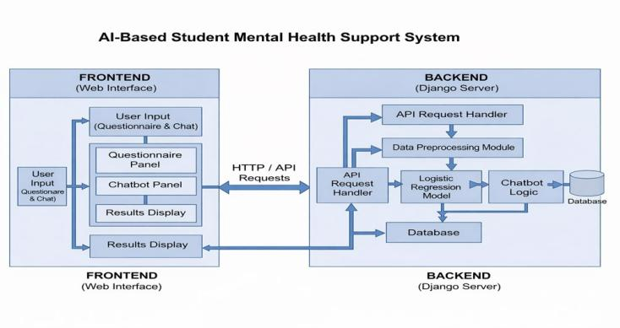
Fig. 1. Step-by-Step Process Flow
- AI-Based Risk Assessment Engine

This is the core intelligence unit of the system. It uses Logistic Regression combined with rule-based logic to evaluate psychological indicators such as stress, anxiety, mood, and sleep patterns. Based on these features, the system classifies students into Low, Moderate, or High mental health risk categories.

- Rule-Based Decision Logic
To ensure transparency and explainability, the system applies rule-based conditions alongside machine learning. These rules define thresholds and symptom patterns, helping the system justify why a student was placed in a particular risk category.

- Chatbot and Recommendation Module
Based on the risk assessment result, the chatbot module generates personalized feedback, self-help suggestions, and supportive messages. This module helps students understand their mental health status and guides them toward positive actions.

- Database Layer
The database stores all student information, assessment results, and chatbot interactions. It maintains historical records, allowing the system to track changes in mental health over time and support continuous monitoring.

- Admin Dashboard
The Admin Dashboard Module provides authorized administrators with a centralized interface to monitor and manage the mental health assessment system. Through this dashboard, staff can view student risk distributions, assessment trends over time, system usage statistics, and overall system health. This enables institutions to gain insights into the mental wellbeing of the student population, identify high-risk cases at an early stage, and make informed decisions regarding timely interventions and support strategies.

v. System Architecture and Design Methodologies

The robustness and effectiveness of the AI-Based Student Mental Health Assessment and Early Risk Detection System are achieved through a layered, modular architecture and iterative design methodologies. This approach ensures high reliability, data security, transparency in decision-making, and adaptability to evolving student mental health needs.
- Architectural Overview
The system is designed using a three-tier architecture that provides logical separation between user interaction, application processing, and data management. This separation improves scalability, simplifies maintenance, and enables independent development and enhancement of each layer.
  - Presentation Layer – The Presentation Layer serves as the direct interface between students, administrators, and the system. It is implemented as a secure web-based application accessible through standard browsers. Students interact with this layer to complete mental health questionnaires, communicate with the AI chatbot, and view their mental health risk level and personalized recommendations. Administrators access a dedicated dashboard to monitor student trends, assessment statistics, and system usage. The layer is optimized for usability and low response time to ensure a smooth and non-intrusive user experience. All inputs, assessment requests, and authentication data are securely transmitted to the backend using HTTPS-based REST APIs..

  - Application Layer – The Application Layer forms the core processing unit of the system and is implemented using a Django-based RESTful framework. This layer manages user sessions, handles incoming requests, and executes the main analysis workflows. It contains the AI-based mental health assessment engine, which receives preprocessed questionnaire data and applies a Logistic Regression model combined with rule-based decision logic to determine the student’s mental health risk level. The Application Layer also manages chatbot response generation, personalized feedback delivery, and the admin data aggregation process. It ensures that all processing is transparent, explainable, and consistent with ethical mental health assessment practices.

  - Data Layer – The Data Layer is responsible for data persistence, integrity, and historical analysis. It stores student profiles, questionnaire responses, risk classification results, and chatbot interaction logs in a secure database. This layer enables longitudinal monitoring of students by maintaining historical records, allowing the system to track mental health changes over time. Strong security mechanisms such as encrypted storage, role-based access control, and secure session handling are employed to protect sensitive mental health information and ensure compliance with privacy standards.
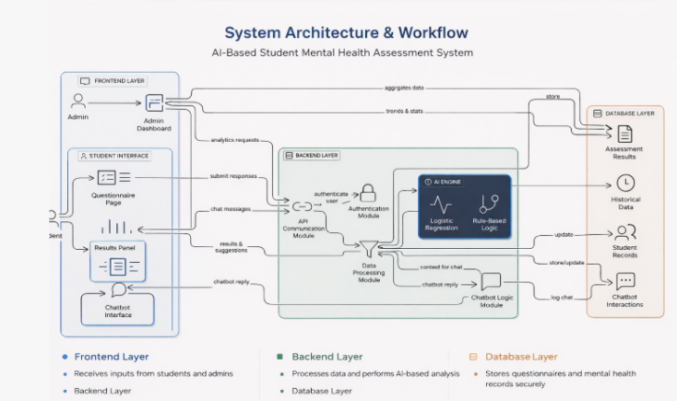
Fig. 2. Three tier architecture

- Design Methodologies

The system development follows a combination of Agile and Modular Design approaches:

  - Modular Design – The system follows a modular architecture in which each functional component operates independently. Modules such as questionnaire processing, AI risk evaluation, chatbot interaction, database management, and admin analytics are designed with high internal cohesion and low external coupling. This modularity allows components to be updated, tested, or replaced without affecting the overall system, enabling continuous improvement of AI models and assessment logic.

  - Agile Development – An Agile development methodology is adopted using short, iterative development cycles. This approach allows continuous feedback from testing and evaluation to refine assessment rules, improve AI model accuracy, and enhance user experience. The agile process supports rapid adaptation to changing student mental health patterns and emerging institutional requirements.

  - Security-First Design – Given the sensitive nature of mental health data, the system is developed following a Secure-by-Design principle. This includes strong user authentication, role-based access for students and administrators, encrypted communication via HTTPS, and strict input validation to prevent unauthorized access or data manipulation. These measures ensure confidentiality, integrity, and trust in the platform.
  - Scalable Infrastructure Design – The backend services are designed to support scalability and future expansion. The modular structure allows integration of advanced AI models, mobile applications, and cloud-based deployments. This ensures that the system can support increasing numbers of users and more complex mental health analytics in the future.

vi. Implementation and Use Cases
The implementation phase translates the system architecture into a robust, scalable, and secure operational platform. Each layer of the system is built using industry-standard technologies to ensure high performance, data integrity, and reliability in real-time mental health monitoring
- Implementation Details
The effective operation of the AI-Based Student Mental Health Assessment and Early Risk Detection System is ensured through a carefully structured technical implementation and its deployment across real-world student and institutional environments. The system transforms the conceptual architecture into a fully functional, intelligent platform by integrating modern web technologies, artificial intelligence, and secure cloud-based infrastructure.

- Frontend (Web Interface) - The frontend provides the primary interaction layer for both students and administrators. Students access the questionnaire page, results panel, and chatbot interface, where they submit responses and receive mental health feedback. Administrators use the admin dashboard to view aggregated statistics, risk distributions, and usage trends. The frontend communicates with the backend through secure HTTP/REST APIs, enabling real-time data exchange

- Backend (Django Framework) - The backend is implemented using the Django web framework, which manages system logic, user authentication, data validation, and API communication. Django handles all requests from the frontend, processes student responses, and forwards data to the AI engine. It also controls data storage, user sessions, and admin-level access to reports and analytics.

- API Communication Module - A dedicated API Request Handler manages communication between the frontend and backend. It receives questionnaire responses, chatbot messages, and analytics requests from users and administrators. These requests are securely routed to the Data Processing Module and AI Engine, ensuring structured and reliable data flow.

- Data Processing Module - The Data Processing Module cleans, normalizes, and formats the student responses before sending them to the AI engine. It extracts meaningful features such as stress level, mood, academic pressure, sleep patterns, and emotional indicators, converting raw questionnaire data into structured inputs suitable for prediction..

- AI Engine (Logistic Regression + Rule-Based Logic) - The core intelligence of the system is implemented using a Logistic Regression model combined with Rule-Based Decision Logic.The Logistic Regression model predicts the probability of mental health risk based on student responses. The Rule-Based Logic applies psychological thresholds and expert-defined conditions to refine the risk classification into low, moderate, or high risk. This hybrid approach improves both accuracy and interpretability of the predictions.

- Chatbot Logic Module - The Chatbot Module provides interactive emotional support. It uses predefined psychological rules and AI-based context to generate meaningful responses. The chatbot receives contextual data from the AI engine and offers emotional guidance, stress management tips, and supportive feedback. All interactions are logged for further analysis.

- Database Layer - The database layer stores all system-related data, including student profiles, questionnaire responses, calculated mental health risk scores, historical assessment records, and chatbot interactions. This centralized data storage enables continuous monitoring and longitudinal analysis of student mental health patterns over time. By maintaining structured and historical records, the system supports accurate trend analysis, early risk identification, and improved decision-making for both the AI engine and administrators.

- Admin Dashboard Module - The Admin Dashboard provides authorized institutional staff with a comprehensive view of the overall system. It displays student mental health risk distributions, assessment trends, system usage statistics, and platform health indicators. Through this dashboard, administrators can identify high-risk student groups, monitor changes in mental health trends, and ensure that the system is functioning effectively, enabling timely intervention and proactive mental healthcare management.

- Supporting Technologies and Deployment

- Data Collection (Questionnaires & Chatbot Inputs)

The Data Collection and Preprocessing Module gathers student mental health data through structured questionnaires and chatbot interactions. The questionnaire captures key psychological indicators such as stress level, academic pressure, mood changes, sleep quality, and emotional wellbeing. The chatbot collects conversational inputs that provide additional emotional context. These inputs are cleaned, standardized, and converted into structured features to ensure accurate and reliable mental health assessment.

- Deployment Integration

The system is deployed on a web-based server environment that supports scalability, reliability, and continuous availability. The Django backend and database are hosted on a secure cloud platform, allowing the system to handle multiple users simultaneously.

- Use Cases
  - Real-Time Mental Health Risk Detection:
When a student submits a questionnaire or interacts with the chatbot, the AI engine immediately analyzes the data and calculates a mental health risk score. The system classifies the student into low, moderate, or high-risk categories and displays the results instantly, enabling early awareness and support.Automated Escalation for Enforcement - The system automatically aggregates multiple verified scam reports and collected evidence (domain info, server IP). This evidence package is swiftly transmitted to the designated cybercrime authorities and hosting providers for domain suspension.

  - Early Warning and Intervention Support:
If a student is detected to be at high mental health risk, the system highlights this status and provides supportive guidance and self-help recommendations. This allows early psychological intervention before the condition worsens.

  - Continuous Student Monitoring:
The system stores all assessment results in the database and tracks changes over time. This enables continuous monitoring of a student’s mental health trends, helping to detect long-term stress patterns or gradual deterioration.

  - System Performance and Security Monitoring:
The backend continuously monitors system activity, database operations, and user access. Any abnormal activity or system issues are logged to ensure data security, platform reliability, and uninterrupted service.tion agencies for public outreach and regulatory action.
VII. Security and Privacy
Security and Privacy
The Intelligent Student Mental Health Monitoring System is designed with strong security and privacy controls to protect sensitive personal and psychological data. Since the system processes confidential student information, including emotional states, stress levels, and mental health indicators, ensuring data confidentiality, integrity, and ethical handling is a primary requirement.
- Data Privacy Protection
All student information collected through questionnaires and chatbot interactions is treated as highly confidential. Personal identifiers such as names, email IDs, or registration numbers are securely stored and separated from mental health data wherever possible. Only authorized users, such as administrators or counselors, are permitted to access sensitive information through role-based authentication..
- Secure User Authentication
The system uses secure login mechanisms for both students and administrators. Passwords are encrypted before being stored in the database, preventing unauthorized access even if the database is compromised. Role-based access control ensures that students can only view their own results, while administrators can access aggregated mental health statistics.

3) Encrypted Data Transmission
All data exchanged between the frontend (user interface) and backend (Django server) is transmitted over secure HTTPS channels. This prevents interception, eavesdropping, and data tampering during communication between users and the system.
4) Secure Data Storage
The database is protected using access control, encryption, and regular backups. Mental health records are stored in a structured and protected format, ensuring that only authorized system services and administrators can retrieve or modify the data.
5) Ethical Use of AI and Student Consent
The system operates under ethical AI principles. Students are informed that their data is being used only for mental health assessment and institutional wellbeing purposes. The AI model does not make final medical diagnoses but provides risk-based predictions to support early intervention.
6) System Monitoring and Protection
The backend continuously monitors login attempts, API requests, and data access patterns. Any suspicious activity or abnormal behavior is logged, helping administrators detect potential security threats and maintain system integrity.
VIII. Performance and Limitations
The Intelligent Student Mental Health Monitoring System demonstrates strong performance in providing real-time emotional assessment, early risk detection, and institutional-level mental health insights. However, like all AI-driven systems, it also has certain limitations that must be acknowledged.
1) System Performance
The system efficiently processes student inputs such as questionnaire responses and chatbot interactions through the backend server, ensuring minimal response time. The use of a lightweight and scalable web framework allows multiple users to access the platform simultaneously without significant performance degradation.The Admin Dashboard presents live updates of student risk levels, usage trends, and overall system statistics.
2) Model Effectiveness
The machine learning model is capable of detecting common mental health patterns based on structured survey data and conversational inputs. It performs well in identifying students who may be at moderate or high risk, allowing timely intervention. As more data is collected, the model continuously improves its prediction accuracy through retraining.

3) Limitations
Despite its effectiveness, the system has several limitations. First, the AI model relies heavily on the quality and honesty of student inputs. If students provide inaccurate or incomplete responses, the predictions may not reflect their true mental state. Second, the system cannot replace professional mental health diagnosis or therapy; it only serves as a decision-support tool.
IX. Result and Discussion
The proposed Intelligent AI-Driven Student Mental Health Assessment System was tested using simulated student self-assessment data representing different mental health conditions such as stress, anxiety, and depression. The system successfully analyzed user responses and classified students into multiple risk levels including low risk, moderate risk, and high risk. The AI-based decision engine and rule-based logic effectively identified early warning signs such as emotional distress, sleep disturbance, lack of motivation, and social withdrawal.
The web interface provided instant feedback to students, displaying their mental health status along with suitable self-care recommendations. At the same time, the Admin Dashboard showed real-time statistics such as the number of high-risk students, overall risk distribution, and assessment trends. This allowed administrators to quickly identify vulnerable students and monitor overall wellbeing.
The system demonstrated stable performance during multiple user interactions, and data was securely stored for further analysis and monitoring. The results indicate that the system can detect mental health risks at an early stage and support timely intervention.
However, the system relies on self-reported data, which may sometimes be inaccurate due to hesitation or lack of awareness among students. Despite this, the system provides a strong foundation for early screening and mental health support.

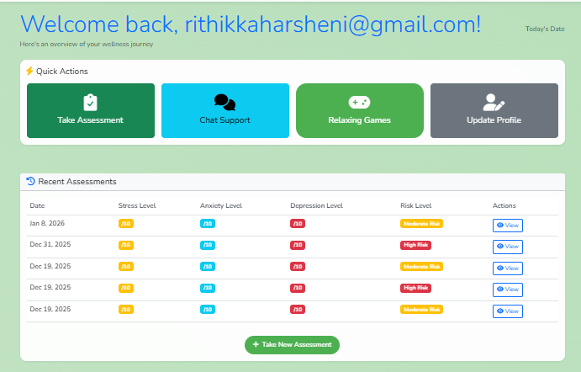 Fig. 1. Dashboard

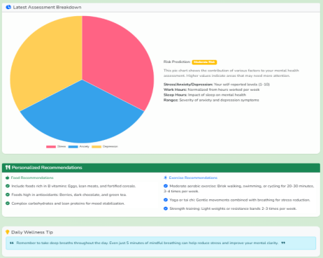
Fig. 2. Pie chart

X. CONCLUSION
This paper presented an Intelligent AI-Driven System for Student Mental Health Assessment and Early Risk Detection designed to support proactive mental healthcare in academic environments. The proposed system effectively analyzes student self-assessment data using AI and rule-based decision logic to identify early signs of stress, anxiety, and depression. By providing real-time feedback, personalized recommendations, and continuous monitoring, the system helps students become more aware of their mental health conditions and seek timely support.Overall, the proposed solution bridges the gap between mental health awareness and early risk detection by combining artificial intelligence with digital healthcare delivery. With further enhancements such as clinical validation, real-time behavioral tracking, and backend integration, the system has strong potential to become a reliable and impactful tool for improving student mental wellbeing.
XI. References
[1] World Health Organization, Mental Health in Young People, WHO Press, Geneva, 2023.
[2] S. Kumar and R. Sharma, “Artificial intelligence in mental health care: Applications and challenges,” IEEE Access, vol. 10, pp. 45612–45625, 2022.
[3] J. Smith and L. Brown, “Web-based mental health assessment systems for students,” Journal of Digital Health, vol. 9, no. 2, pp. 65–78, 2021.
[4] A. Patel, M. Verma, and P. Singh, “Machine learning approaches for depression detection,” International Journal of Healthcare Informatics, vol. 14, no. 3, pp. 120–132, 2021.
[5] T. Nguyen, D. Phung, and S. Venkatesh, “Deep learning for mental health diagnosis,” ACM Computing Surveys, vol. 54, no. 6, pp. 1–36, 2021.
[6] R. B. Patel and K. Mehta, “Security and privacy in healthcare information systems,” Journal of Cybersecurity in Healthcare, vol. 5, no. 1, pp. 40–52, 2022.
[7] M. Chen, Y. Hao, K. Hwang, and L. Wang, “Disease prediction using machine learning in healthcare,” IEEE Access, vol. 5, pp. 8869–8879, 2017.
[8] S. Kaur and R. Singh, “Rule-based expert systems for mental disorder detection,” International Journal of Computer Applications, vol. 178, no. 10, pp. 28–35, 2019.
[9] A. Alhassan et al., “AI-based emotion and stress detection,” Sensors, vol. 21, no. 14, pp. 1–19, 2021.

